

Temperature distribution within a ceiling jet propagating in an inclined

fl

at-ceilinged tunnel with natural ventilation

Yasushi Oka

a

,

n

, Osamu Imazeki

b

Contents lists available at

[t](http://www.sciencedirect.com/science/journal/03797112)

ScienceDirec

journal homepage:

www.elsevier.com/locate/firesa

[f](http://www.elsevier.com/locate/firesaf)

Fire Safety Journal



Fire Safety Journal 71 (2015) 2

[0](http://dx.doi.org/10.1016/j.firesaf.2014.11.002)

[–](http://dx.doi.org/10.1016/j.firesaf.2014.11.002)

[3](http://dx.doi.org/10.1016/j.firesaf.2014.11.002)

[3](http://dx.doi.org/10.1016/j.firesaf.2014.11.002)

a

Safety Management Course, Faculty of Environment and Information Sciences, Yokohama National University, 79-7 Tokiwadai, Hodogaya-ku, Yokohama

240-8501, Japan b I.T. Solution Department, Kajima Corporation, 6-5-30 Akasaka, Minato-ku, Tokyo 107-8502, Japan

|  |  |
| --- | --- |
| a r t i c l e i n f o | a b s t r a c t |

|  |  |
| --- | --- |
| Article history:  Received 9 December 2013  Received in revised form  27 September 2014  Accepted 23 November 2014 Available online 1 December 2014  Keywords:  Temperature distribution  Ceiling jet  Inclined flat-ceilinged tunnel  Natural ventilation | In this study, we conducted detailed measurements of the temperature distribution within a steady firedriven ceiling jet, formed in a tunnel with a rectangular cross-section. We then compared the measured temperature distributions with those for an unconfined smooth-ceiling jet flow, and estimated the relative errors between them. The results showed that the temperature distribution in a horizontal tunnel exhibits a greater bulge than that of a ceiling jet under an unconfined ceiling and varied from a bulging shape to an exponential shape as the tunnel inclination increased. We propose a new correlation for representing the temperature distribution, which takes the tunnel inclination into account, and which consists of an exponential function and a cubic function with a coordinated transformation.  & 2014 Elsevier Ltd. All rights reserved. |

# Introduction

Tunnels are indispensable to the high-speed mass transit networks that carry goods and passengers. In terms of spatial characteristics, a tunnel can be defined as having an axially elongated length relative to the width and height of its cross-section. Unfortunately, significant and fatal accidental tunnel fires occur on an annual basis [1]. Such fires could potentially become much worse in the future as new, longer tunnels are constructed and as traffic densities increase. The behaviour of a fire in a tunnel, as represented by the flame shape, hot current flow, and other parameters, differs from that of a building fire given the structural factors and the effect of ventilation.

Based on previous data obtained in full-scale [2–5] and smallscale [6–9] experiments, as well as from numerical calculations [10,11], researchers have developed easy-to-use correlations between the maximum ceiling gas temperature and its position [12– 14], the critical velocity [15–19], the temperature reduction along the tunnel axis [20–23], and the backlayering length [24,25].

Most studies of tunnel fires have been conducted in a horizontal tunnel. However, the ramps that connect the surface to underground tunnels, which tend to be constructed at considerable depths to make the best use of the underground space in urban areas, are, by necessity, steeply sloped. Therefore, the temperature distribution within the ceiling jet flow in these inclined

|  |
| --- |
| n Corresponding author. Fax: þ81 45 339 4011. E-mail address: y-oka@ynu.ac.jp (Y. Oka).  <http://dx.doi.org/10.1016/j.firesaf.2014.11.002>  0379-7112/& 2014 Elsevier Ltd. All rights reserved. |

tunnels will be different from that of a ceiling jet in a horizontal tunnel and also from that under an unconfined inclined ceiling. Previous studies have focused on the temperature distribution within a ceiling jet flowing under an unconfined horizontal or inclined flat ceiling [26–29]. However, the extent to which these correlations are applicable to tunnels in which the side walls disrupt the radial expansion of the ceiling jet has not yet been clarified.

For this study, our objective was to accurately and systematically measure the temperature distribution in the ceiling jet that propagates along the tunnel axis in an inclined tunnel and to develop a correlation to represent the temperature distribution as a function of the inclination of the tunnel.

# Experimental procedure

We conducted a series of fire tests in a test room with interior dimensions of 13.2 m (L) 7.5 m (W) 6.0 m (H). A model tunnel having a rectangular cross-section with dimensions of 10.0 m (L) 0.75 m (W) 0.45 m (H) was constructed, as shown in Fig. 1(a). We constructed the tunnel ceiling using 12 mm calcium silicate boards with a smooth surface finish. The sidewalls were 10-mm transparent poly(methyl methacrylate) (PMMA) board, which would allow us to observe the hot current flow and fresh air backflow. For the floor, we used 9.5-mm plywood, except for the area around the fire source, for which we used 12-mm calcium silicate board. Both ends of the tunnel were left completely open to enable the unrestricted flow of both the hot gas flowing out of the tunnel and the fresh air being drawn into the tunnel. The inclination was set to 0°, 3°, 5°, 8°, and 10°.

We used two fuels in this study: methanol and liquefied petroleum gas (LPG), with propane being the major component of the latter. To burn the methanol, we used two fuel pans made of 2-mm stainless steel, one measuring 0.10 m 0.10 m and the other 0.15 m 0.15 m. Both pans were 30 mm deep. The fuel pool was rested on an electric balance (LP 8200 S, Sartorius; precision: 0.01 g) to allow us to measure the mass loss. For the experiment using LPG, the fuel was supplied to a diffusion gas burner through a mass flow controller (M100B, MKS Instruments). We used a gas burner measuring 0.1 m 0.1 m that we filled with fine porous aggregate. The fuel pan and gas burner setups in the inclined tunnel are shown in Fig. 1(b). For the methanol, the fuel pan was separated from the electric balance by a stand and the surface of the fuel pan was kept horizontal. We provided a small hole for the support strut that passed under the fuel pan. For the experiment using liquefied propane gas, we set up the square porous burner such that its top surface was at the same level as the tunnel floor.

We estimated the heat release rates from the mass loss or flow rate and the heat resulting from the combustion of the fuel, based on the values calculated by assuming complete combustion. It is generally believed that the source of the driving force of the ceiling jet is the convective component of the total heat of combustion. Then, we used the convective heat release rate to analyse the experimental data. We assumed the convective heat resulting from the combustion of the methanol and LPG to be 16.1 and 31.2 MJ/kg, respectively, and the heat of combustion to be 19.1 and

43.7 MJ/kg, respectively [30].

We suspended fifty-seven thermocouples 10 mm below the centre line of the tunnel ceiling, as shown in Fig. 1(c). We installed thirty copper-constantan (T-type) thermocouples at points between 0.6 m and 3.5 m, relative to the centre of the fire source, at 0.1 m intervals. We also installed fourteen chromelalumel (K-type) thermocouples at points between 0.5 m and þ0.55 m, specifically at 0.5, 0.4, 0.3, 0.2, 0.1, 0, 0.05, 0.1,

0.15, 0.2, 0.25, 0.3, 0.4, and 0.55 m. In the range from þ0.9 m to

6.3 m, we installed thirteen T-type thermocouples at 0.9, 1.35, 0.8, 2.25, 2.7, 3.15, 3.6, 4.05, 4.4, 4.95, 5.4, 5.85, and 6.3 m. The strand wire diameter of the thermocouples was 0.2 mm.

We measured the ceiling jet temperature distribution along the centre plane, perpendicular to the tunnel ceiling, using thermocouple rakes with K- and T-type thermocouples. The K-type thermocouples were set in the near field of the fire source, while the T-type thermocouples were set in the far field. Each thermocouple rake had twelve thermocouples and was oriented relative to the tunnel ceiling as shown in Fig. 1(d). We positioned the thermocouples at points 5, 10, 20, 30, 40, 55, 70, 100, 140, 180, 230, and 300 mm from the tunnel ceiling. We performed the temperature measurements twice under the same conditions but with two different thermocouple rake settings. For the first rake, denoted as “rake-1,” we set the thermocouples at 0.75, 1.5, 3.5, and 5.5 m from the centre of the fire source. For the second rake, denoted as “rake2,” we set the thermocouples at 1.0, 2.0, 3.0, and 4.4 m from the centre.

Nomenclature

a

,

b

Coef

fi

cients in Eq.

(3)

representing the temperature

distribution de

fi

ned by a cubic function

H

Tunnel height [m]

L

T

Thermal thickness [m]

L

_

Δ

T

max

Distance from the centre of the

fi

re source to the point

at which the maximum gas temperature arises

Q

C

Convective heat release rate [kW]

Q

t

Total heat release rate [kW]

x

Distance along the tunnel axis from the point at which

Δ

_

*T*

max

ceiling

the maximum ceiling gas temperature

appears [m]

z

Distance perpendicular to the ceiling from tunnel

ceiling surface [m]

z

apex

Distance from the point at which the apex of the

temperature distribution appears perpendicular to the

tunnel ceiling

Δ

*T*

Temperature rise [K]

Δ

*T*

max

Maximum temperature rise at the apex of tempera-

ture distribution in perpendicular direction to tunnel

ceiling [K]

Δ

_

*T*

ceiling

max

Maximum

ceiling

gas

measured

temperature

10

mm below the tunnel ceiling [K

]

⁎

*Q*

*c*

Dimensionless heat release rate [-],

*ρ*

=

∞

∞

*Q*

*H*

*C T g*

/(

)

*c*

*p*

2

5

/

2

/

1

Greek

α

,

β

,

γ

,

η

Coef

fi

cients in Eq.

(2)

representing the temperature

distribution de

fi

ned by an exponential function

ε

Relative error

θ

Inclination angle of tunnel [

°

]

Subscripts

Ceiling

c

∞

Atmosphere

The measured temperatures include the effect of the heat being radiated from the flames as well as that from the heated sides and ceiling of the tunnel. We recorded the temperature and fuel mass loss data at 1 s intervals by using a data logger (MX110, Yokogawa), and stored this data on a PC for further analysis. Data collection was started 60 s before the fuel was ignited. We ran each test for at least 10 min. During these tests, we shut down the forced ventilation in the laboratory and closed all the doors to the test room.

# Results and discussion

3.1. Heat release rate

Table 1 lists the results obtained for the heat release rate. The repeatability or variability of the experiments was within 77%, as regards the heat release rate of the fire. To calculate the heat release rate of the methanol, we used the Douglas-Avakian numerical differentiation method. We performed the calculation using the data obtained during the quasi-steady state existing 420–520 s after ignition. For the LPG fire, the heat release rate was adjusted to two different values of 4.48 kW and 8.89 kW. Applying this to a full-scale tunnel with a height of 7 m, the heat release rate range of 3.40–8.89 kW in this experiment would correspond to a range of 3.2–8.5 MW, as determined using Froude modelling. This approximates to the values that would be generated by a passenger vehicle fire.

|  |
| --- |
| Fig. 1. Experimental setup and thermocouple positions (a) outline of model tunnel, (b) fuel and gas burner placement in inclined tunnel, (c) positions of thermocouples set 10 mm below the tunnel ceiling, and (d) positions of thermocouples of rake-1 and rake-2, numbers indicate the distance between thermocouples. |

3.2. Temperature decrease of backlayer and position of its head in an inclined tunnel

Fig. 2(a) and (b) shows the effects of the temperature decrease in the backlayer that is propagated downwards in the inclined tunnel. We confirmed that the slope of the temperature decrease of the backlayer with distance becomes steeper as the inclination of the tunnel increases. This means that the distance from the centre of the fire source to the head of the backlayer decreases as the inclination of tunnel increases. Given that the position of the backlayer head is defined as that point at which the temperature rise of the backlayer drops to 2 K, the relationship between the distance of travel of the head of the backlayer and the inclination of the tunnel is as shown in Fig. 3. The origin of the movement of the head of the backlayer is the centre of the fire source. From this figure, we can assume that the head of the backlayer remains in the inclined tunnel; in other words, it does not move out of the downward end. We conducted at least two tests at each inclination while varying the heat release rate and the type of fuel, and then plotted the results.

3.3. Maximum temperature rise and position of the ceiling jet along the tunnel axis

The position of the maximum temperature rise in the ceiling jet is given as the distance from the centre of the fire source to the point where the maximum gas temperature appears along the tunnel axis and is denoted as L_ΔTmax. Instead of directly reading the maximum temperature rise as measured at a point 10 mm below the ceiling of the tunnel, we employed an estimated maximum temperature rise and position, based on a quadratic fit to the measured data for three points including the maximum temperature rise. This estimated maximum temperature rise is denoted by Δ*T*max _ceiling. The accuracy of this estimate of the maximum temperature rise and its position is dependent on the interval between the thermocouples installed 10 mm below the ceiling of the tunnel. The thermocouples in the area close to the fire source were installed at 50-mm intervals. Fig. 4 shows typical variations in L_ΔTmax with the inclination of the tunnel. We can see that the maximum ceiling gas temperature position, 10 mm

Table 1

Heat release rates used in this study.

|  |  |  |  |
| --- | --- | --- | --- |
| Angle [°] | Size of fuel pan (m2) | Qt [kW] | TC rake position |
| 0 | 0.10 | 3.40 | rake-1 |
|  |  | 3.46  3.63 | rake-2 |
|  | 0.15 | 8.02 | rake-1 |
|  |  | 7.90 | rake-2 |
|  | 0.10a | 4.48  8.89 | rake-2 |
| 3 | 0.10 | 3.21 | rake-1 |
|  |  | 3.26 | rake-2 |
|  | 0.15 | 6.73 | rake-1 |
|  |  | 6.84 | rake-2 |
|  | 0.10a | 4.48 | rake-1 |
|  |  | 8.89 | rake-2 |
| 5 | 0.10 | 3.21 | rake-1 |
|  |  | 3.16 | rake-2 |
|  | 0.15 | 6.71 | rake-1 |
|  |  | 6.62 | rake-2 |
|  | 0.10a | 4.48 | rake-1 |
|  |  | 8.89 | rake-2 |
| 8 | 0.10 | 3.34 | rake-1 |
|  |  | 3.25 | rake-2 |
|  | 0.15 | 6.59 | rake-1 |
|  |  | 6.70 | rake-1 |
|  |  | 6.50 | rake-2 |
|  | 0.10a | 4.48 | rake-1 |
|  |  | 8.89 | rake-2 |
| 10 | 0.10 | 3.37 | rake-1 |
|  |  | 3.46 | rake-2 |
|  | 0.15 | 6.38 | rake-1 |
|  |  | 6.87 | rake-2 |
|  | 0.10a | 4.48 | rake-1 |
|  |  | 8.89 | rake-2 |

a LNG employed as fuel.

below the ceiling of the tunnel, moves from the centre of the fire source to a point upstream as the inclination of the tunnel increases. This position can be represented as a function of the heat release rate, incoming flow velocity and representative length of the tunnel geometry [31].

Fig. 5(a) shows the relationship between the average dimensionless temperature rise and the tunnel inclination. Here, the “average temperature rise” refers to the representative temperature rise at the point where the plume trajectory impinges on the tunnel ceiling. This is estimated from the temperature measured with the installed thermocouples within a range of 0.2ox/ Ho0.2. Here, x is the distance along the tunnel axis from the point at which Δ*T*max _ceiling appears. We assumed that the point at which Δ*T*max _ceiling appears coincides with that at which the plume trajectory impinges on the tunnel ceiling. The dimensionless temperature rise decreases as the tunnel inclination increases. This is due to the increase in the inclination of the flame with that of the tunnel. Here, the inclination of the flame is defined as the angle between the perpendicular and the inclined tunnel floor. Fig. 5 (b) shows that the temperature ratio, obtained by dividing the representative temperature rise in the inclined tunnel by that in the horizontal tunnel, decreases exponentially with an increase in the inclination.

3.4. Repeatability

Fig. 6 compares the temperature distributions that we obtained in the experiments that were performed twice under the same conditions, that is, with the thermocouple rake setting for rake-1

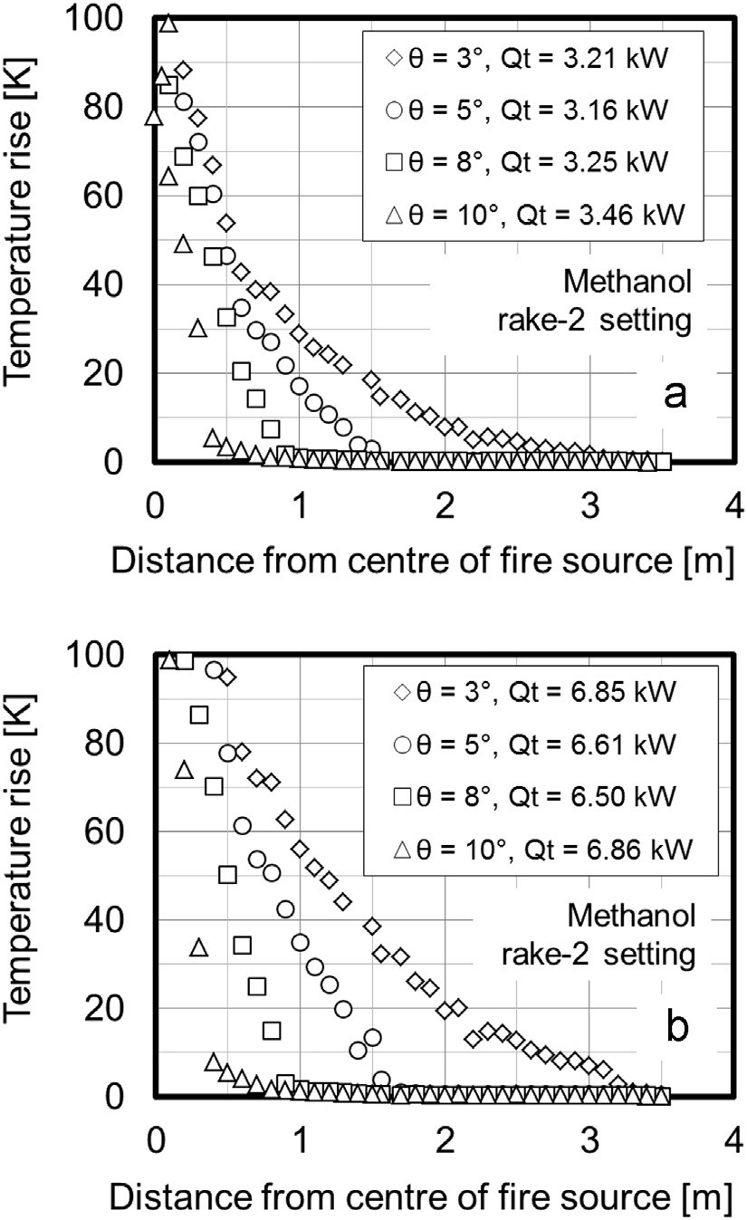

Fig. 2. Temperature rise in the backlayer propagated in the downward direction with a change in the inclination of the tunnel (a) fuel pan: 0.10 m 0.10 m and (b) fuel pan: 0.15 m 0.15 m.

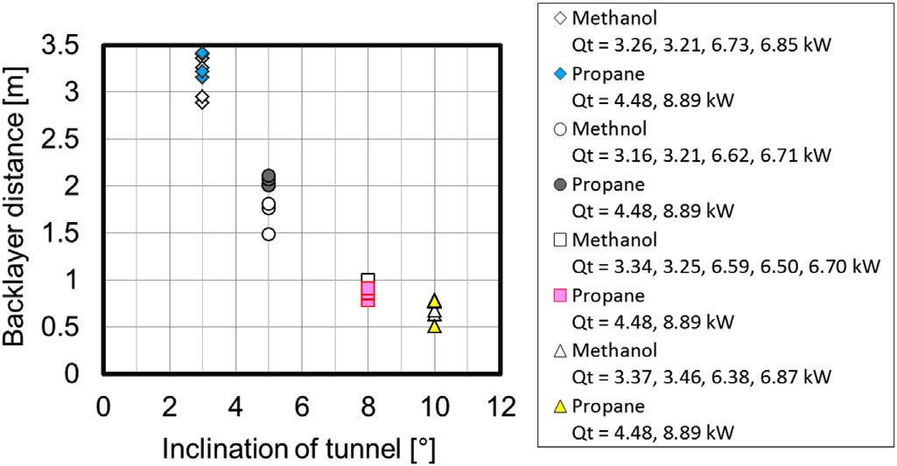

Fig. 3. Backlayering distance in downward direction. Origin is centre of the fire source.

and using the fuel pan measuring 0.10 m 0.10 m. We were able to achieve good repeatability. Here, x is the distance from the measured point to the point at which Δ*T*max _ceiling appears. We believe that the empirical correlations, described below, for predicting the distribution of the ceiling gas temperature are reliable.

3.5. Temperature distribution in direction perpendicular to tunnel ceiling

Fig. 7(a) shows the temperature distribution measured at four typical points in the direction perpendicular to the tunnel ceiling. The temperature distribution exhibits a convex shape with the maximum temperature rise at the apex at each measured position. Instead of directly reading the maximum temperature rise from the measured temperature distribution, we used the estimated

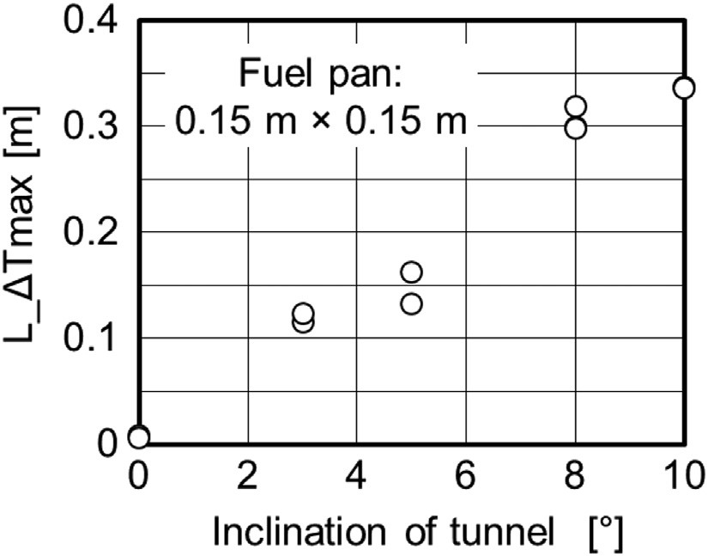

Fig. 4. Variation in distance from centre of the fire source to point where maximum gas temperature rise appears with inclination of tunnel.

maximum temperature and its position as obtained from a quadratic fit to the measured data for three points. Here, Δ*T*max was assigned as the apex of the quadratic function. As the position of the apex gradually moves towards the tunnel floor and Δ*T*max decreases as the distance from the fire source increases, the convex temperature distribution changes to a gradually decreasing distribution. We observed similar temperature distribution changes in inclined tunnels as shown in Fig. 7(b–e).

Research into the velocity distribution in a turbulent wall jet has shown that similarities in the velocity distribution can be preserved by normalising the measured velocity by the maximum velocity in velocity distribution and the half width of the wall jet at each measured position [32]. In the same way, to eliminate the influence of the difference in the distribution shape with distance, the temperature rise and perpendicular distance from the ceiling were normalised by dividing them by Δ*T*max and the thermal thickness, LT, respectively, at each point at which we measured the temperature distribution. The definition of LT is shown in Fig. 8. The thickness of the thermal boundary layer, δTmax, corresponds to that part of the ceiling jet where the temperature varies from the wall temperature to Δ*T*max. The thermal thickness, LT, is represented by the sum of the thermal boundary layer thickness and the length from the apex to the point at which the temperature rise above the ambient value drops to 1/e of Δ*T*max. We also estimated the position of 1/e of Δ*T*max by applying straight-line approximation to three measured points holding the position of 1/e of Δ*T*max. The normalised temperature distributions coalesced to the same line independently of the distance from the point at which Δ*T*max _ceiling appears, as shown in Fig. 9(a). This trend is the same for each inclination of the tunnel, as shown in Figs. 9(b–e).

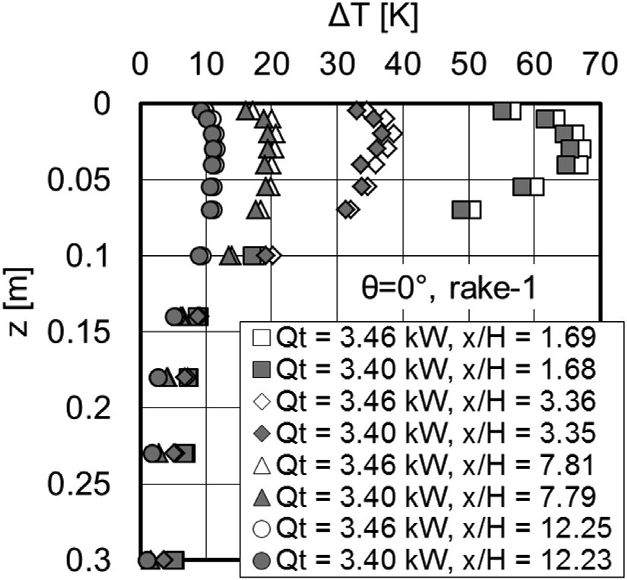

Fig. 6. Comparison of temperature distribution to check repeatability of experiments.

In Fig. 10, the results are superimposed on the normalised temperature distributions in the direction perpendicular to the tunnel ceiling, as obtained for different heat release rates, by applying a similar analysis method to that employed in Fig. 9. We confirmed that the normalised temperature distributions coalesced to the same line without being dependent on either the measured distance or the heat release rate. In addition, we can see that this property is retained regardless of the inclination.

The temperature distribution within the ceiling jet in a horizontal tunnel exhibits a more bulging shape, reflecting the distribution shape of the region in which the temperature rise decreases gradually from the apex of the temperature distribution to the tunnel floor, than that in an inclined tunnel. The data for a horizontal tunnel indicates that the temperature decreases more slowly from the position of Δ*T*max. However, we confirmed that this bulging shape in the temperature distribution gradually disappears as the tunnel inclination increases.

3.6. Comparison with existing correlations of temperature distribution

Several correlations for representing the temperature distribution within a ceiling jet have been devised. These include Motevalli and Marks [26], Cooper [27], and Oka et al. [28,29]. These correlations were derived based on experimental data that was obtained for unconfined flat ceilings. The correlations derived by Motevalli and Marks [26] and Cooper [27] represent the

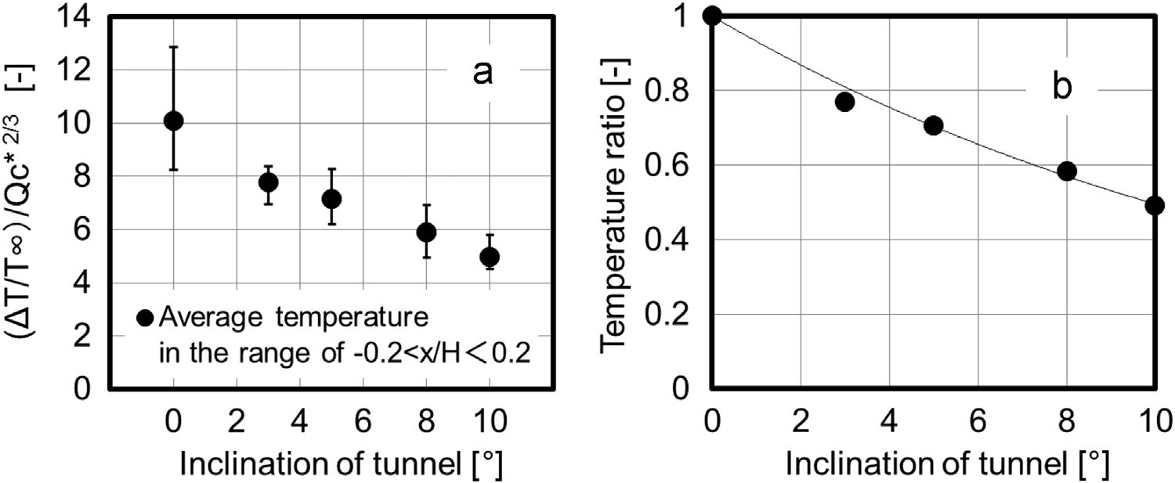

Fig. 5. Variation in averaged temperature rise in the region of 0.2ox/Ho0.2 with tunnel inclination. Here x is the distance along the tunnel axis from the point at which the maximum temperature rise appears.

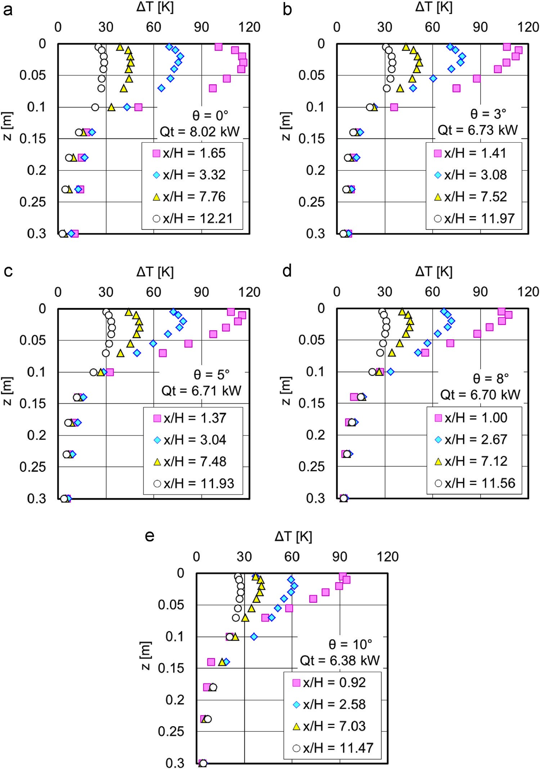

Fig. 7. Temperature distributions measured at four typical points in direction perpendicular to tunnel ceiling in each inclined tunnel.

temperature distribution within a ceiling jet that flows under a smooth horizontal and unconfined ceiling. On the other hand, those of Oka et al. [28,29] can be applied to the prediction of the temperature distribution within a ceiling jet both under a smooth horizontal and inclined unconfined ceiling. Therefore, we examined the differences between the temperature distributions predicted using these correlations and those observed in the tunnel.

Fig. 11 shows a comparison between the measured/predicted temperature distributions and the correlations of Motevalli and Marks, Cooper, and Oka et al. The Motevalli and Marks and Cooper correlations represent the temperature distribution by applying exponential and trigonometric functions, respectively. Oka et al. represented the temperature distribution by applying either an exponential function or a cubic function with the coordinate transformation, taking into account the inclination of the unconfined ceiling. As is shown in Fig. 11(a), the temperature distribution within the ceiling jet in a horizontal tunnel shows a greater degree of bulging than that under an unconfined ceiling. The values obtained in the tunnel decrease more slowly from the apex even though the correlations of Cooper [27], and Oka et al. [29] were devised to represent the bulging shape of the temperature distribution. The bulging shape of the temperature distribution becomes smaller as the inclination of the tunnel increases, as shown in Fig. 11(b–e). However, we cannot approximate the temperature decay merely by using the exponential function.

Fig. 12(a) shows a comparison of the relative error, as calculated with Eq. (1), between the temperature distributions obtained with

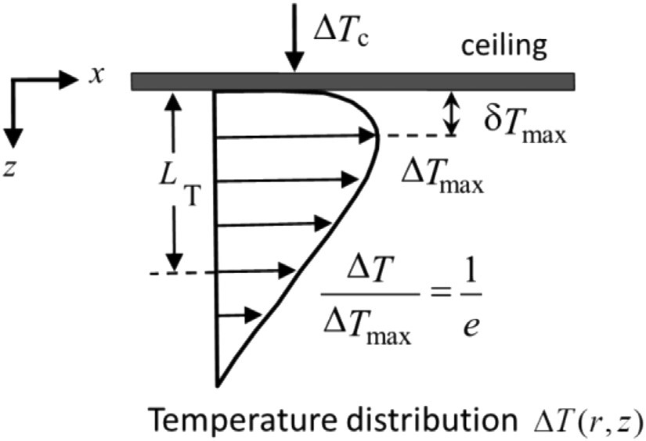

Fig. 8. Schematic of ceilingjet and its characteristic parameters.

the existing correlations and the data obtained in the horizontal tunnel. The range of the comparison is 0oz/LTo1. The correlations of Cooper or Oka et al. [29] exhibit a smaller degree of error than those of Motevalli and Marks [26] and Oka et al. [28]. Cooper's and Oka's correlations can be improved to represent the bulging shape of the temperature distribution by using the exponential approximation.

*n*

∑

∑

*ε*

−

=

=

*n*

*x*

*y*

1

(

)

/

1

*i*

*n*

*i*

*i*

1

2

*n i*=1*yi* (1)

The results of examining the influence of the tunnel inclination on the measured and predicted values are shown in Fig. 12 (b). The relative error between the measured values and those predicted by using the correlation of Oka et al. [28], as

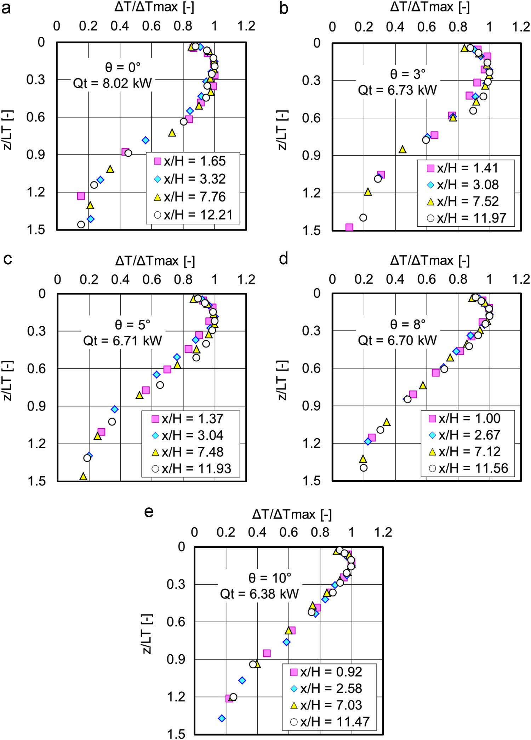

Fig. 9. Normalised temperature distributions at each inclination with changes in measured position for each inclination of tunnel.

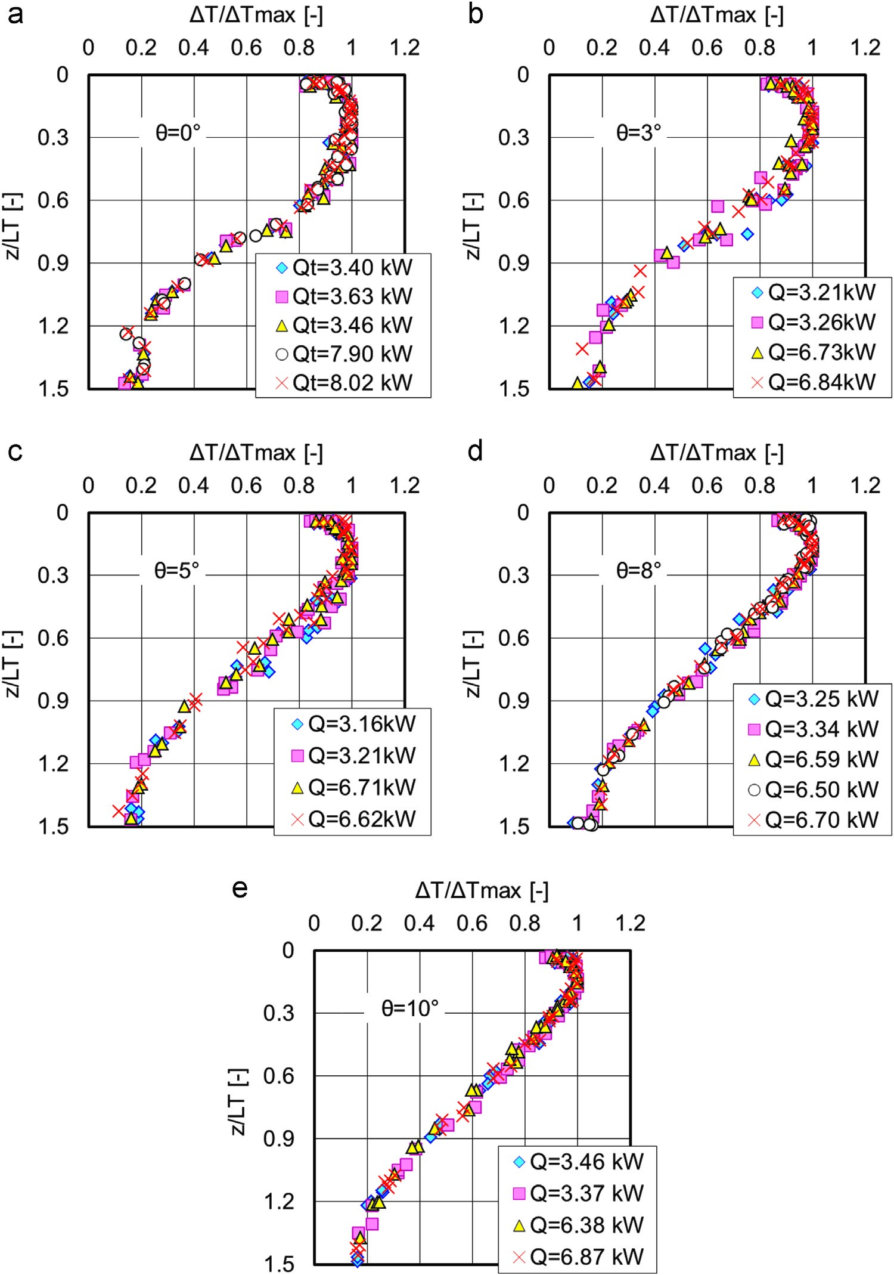

Fig. 10. Normalised temperature distributions at each inclination with changes in heat release rate for each inclination of tunnel.

approximated by an exponential function, becomes smaller as the inclination increases. This means that the temperature distribution approaches the exponential shape as the tunnel inclination increases.

Although the relative error between the measured values and those predicted using a correlation composed of a cubic function and a coordinate transformation [29] is no more than 5%, regardless of the inclination, we recalculated the values of the coefficients in the correlation based on the data obtained from the experiments performed in the tunnel. The appendix provides details of how to determine the values of the coefficients in

Eqs. (2) and (3). *z L*/ *T* < *z*apex = *α*⎜⎝⎛ + *β*⎞⎟⎠*γ*exp⎛⎜⎝−*η* ⎞⎟⎠

Δ*T z z*

Δ*T*max *LT LT* (2)

α ¼3.033, β ¼0.06566, γ ¼0.5185, η¼2.1208, *z*apex = *γ η*/ − *β*

*z L*/ *T* ≥ *z*apex

*Y aX X b X b b*= ( + )( − ), ≥ 0 (3)

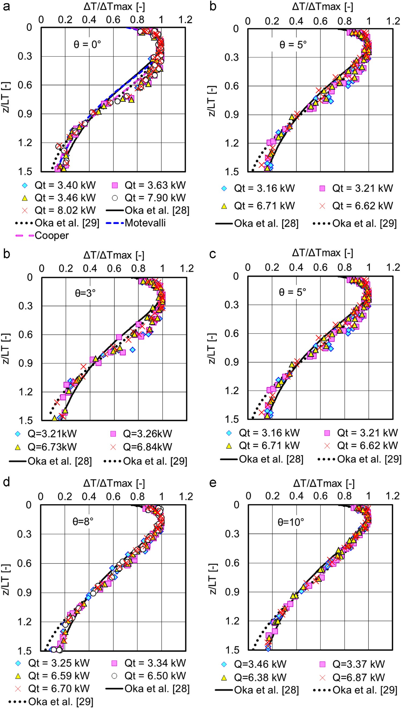

Fig. 11. Comparison between existing correlations and measured data for each inclination of tunnel.

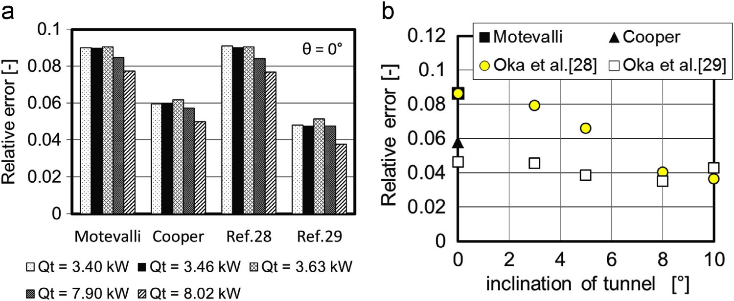

Fig. 12. Comparison of relative error between measured and predicted values.

⎢⎡⎢⎣ *z L*/ *T* ⎤⎥⎥⎦ ⎡⎢⎣cos *ϕ* − sin *ϕ*⎦⎤⎥⎢⎣⎡*X*⎤⎥⎦ ⎡⎢⎣*x*0⎤⎦⎥

= +

Δ Δ*T T*/ max sin *ϕ* cos *ϕ Y y*0

*a* = 0.6178, *b* = (*x*0 − *z*apex)2 + −(*y*0 1)2 ,

|  |  |
| --- | --- |
| *x*0 = 0.7964, *y*0 = 0.5788 cos *φ* = (*x*0 − *z*apex)/ , sin*b ϕ* = −(*y*0 1)/*b* | (4) |

Based on the above discussion, we developed a new correlation which can predict the temperature distribution within a ceiling jet in a tunnel with a rectangular cross-section of 0.75 m (W) 0.45 m (H). This is given by the set of Eqs. (2)–(4). The values of the coefficients representing the temperature distribution are given by Eqs. (5)–(8) as a function of the inclination of the tunnel. These correlations are composed of two functions. The first represents the temperature distribution using an exponential function, which covers the region from the ceiling surface to the apex of the temperature distribution. The distance from the apex of the temperature distribution to the tunnel ceiling is denoted by zapex. This correlation is the same as that reported in reference [28]. The second is a cubic function that covers the region from the apex to the position at which the temperature drops to 1/e of Δ*T*max in the direction perpendicular to the tunnel ceiling.

3.7. Proposal of a correlation for temperature distribution accounting for the inclination angle

|  |
| --- |
| Fig. 13. Variation in coefficients a, x0 and y0 with inclination of tunnel. |

By applying a similar method to the deviation in the temperature distribution function in a horizontal tunnel, we determined the values of each coefficient in the cubic function using the data obtained at each tunnel inclination. Fig. 13 shows the variation in each coefficient with the tunnel inclination, which is also expressed in Eqs. (6)–(8). Note that this correlation applies to tunnels with a rectangular cross-section of 0.75 m (W) 0.45 m (H). Care should be taken if they are to be applied to tunnels with different geometries, such as those with a different cross-sectional aspect ratio and those with an arched as opposed to flat ceiling.

*z L*/ *T* < *z*apex *α* = 3.033 − 1.163{1 − exp( − 0.106 )}*θ β* = 0.0657 − 0.0514{1 − exp( − 0.112 )}*θ γ* = 0.519 − 0.305{1 − exp( − 0.107 )}*θ*

*η* = 2.121 − 0.473{1 − exp( − 0.0791 )}*θ* (5)

*z L*/ *T* ≥ *z*apex

*a* = 6.178 × 10−1

− 3.840

× 10−1⎨⎩⎧ 12 ⎫⎬⎭

1 + 6.473 × 10 exp( − 1.278 )*θ* (6)

*x*0 = 7.964 × 10−1

− 7.720 × 10−2⎨⎩⎧ 12 ⎫⎬⎭

1 + 1.535 × 10 exp( − 1.203 )*θ* (7)

*y*0 = 5.788 × 10−1

+ 2.330 × 10−2⎨⎩⎧ 1 ⎫⎬⎭

1 + 1.370 × 105exp( − 2.993 )*θ* (8)

3.8. Application of the developed correlation to data obtained in small-, large-, and full-scale tunnels

We obtained the temperature distributions for two types of horizontal tunnel from reference [8]. One was a 1/3 scale model of a small road tunnel for passenger cars for which tests were conducted to study the environment facing evacuees in the event of a tunnel fire. The tunnel was built using autoclaved lightweight aerated concrete panels with a thickness of 37 mm. The tunnel was 1.926 m wide, 1.0 m high, and 41 m long with no gradient. N-heptane was employed as the fuel and the heat release rate was varied from 80 to 320 kW. The temperature was measured by using K-type thermocouples with a strand diameter of 0.1 mm. Each thermocouple rake was configured using nine thermocouples, the first being set 20 mm below the tunnel ceiling and other eight being set at z¼0.1–0.8 m at intervals of 0.1 m, perpendicular to the tunnel ceiling. The temperatures reported in reference [8] were for a quasi-steady burning period.

The other was a full-scale road tunnel that is used only for experiments and which features a double-layer structure with a carriageway and an upper ventilation space. This tunnel was made of reinforced concrete and was 9.8 m wide, 4.7 m high, and 400 m long with no gradient. Methanol was used as the fuel and was burned in an 8 m2 fuel tray. The fire source was placed 80 m from one opening. The temperature was measured using thermocouple rake which were placed at distances of 20 m, 40 m, 80 m, and 120 m from the centre of the fire source.

Both tunnels had a rectangular cross-section. We took the temperature distributions described in Fig. 9 and 19 in reference [8] and converted them to a dimensionless temperature rise normalised by the maximum temperature rise. We also normalised the dimensionless length from the tunnel ceiling according to the ceiling jet thickness. Although both experiments used an insufficient number of measurement points in the vertical temperature distribution, especially near the tunnel ceiling, we could nevertheless calculate the apex of the temperature distribution and ceiling jet thickness.

Fig. 14 shows a comparison of the temperature distributions obtained in the large- and full-scale horizontal tunnels, the proposed correlation as defined by the combination of an exponential function, Eq. (2), and a cubic function with coordinate transformation, Eqs. (3) and (4). We confirmed that the temperature distributions in large- and full-scale tunnels coalesce on the line represented by these correlations under various constraints. The average relative error in the range of 0oz/LTo1 for the nine types of data represented in Fig. 14 was 0.06.

Fig. 15 shows a comparison of the temperature distributions obtained in the small-scale inclined tunnel with LPG used as the fuel, together with the newly proposed correlations that consider the effect of the tunnel inclination, as described in Eqs. (2)–(8). The variation in the relative error between the experiments and the values calculated for different tunnel inclinations are also presented. The temperature distribution within the ceiling jet changes from a bulging to an exponential shape as the inclination of the tunnel increases. Based on the results discussed in this paper, we recommend that the correlations represented by the combination of an exponential function, Eqs. (2) and (5), and the cubic function with coordinate transformation, Eqs. (3), (4) and (6)–(8), can be applied for a tunnel inclination of up to 5°. The correlations represented by the exponential function, Eqs. (2) and (5), can be applied to a tunnel inclination of more than 5°.

# Conclusions

We conducted a series of tests to investigate the effect of a tunnel's inclination on the temperature distribution within a steady fire-driven ceiling jet. The tunnel had a rectangular

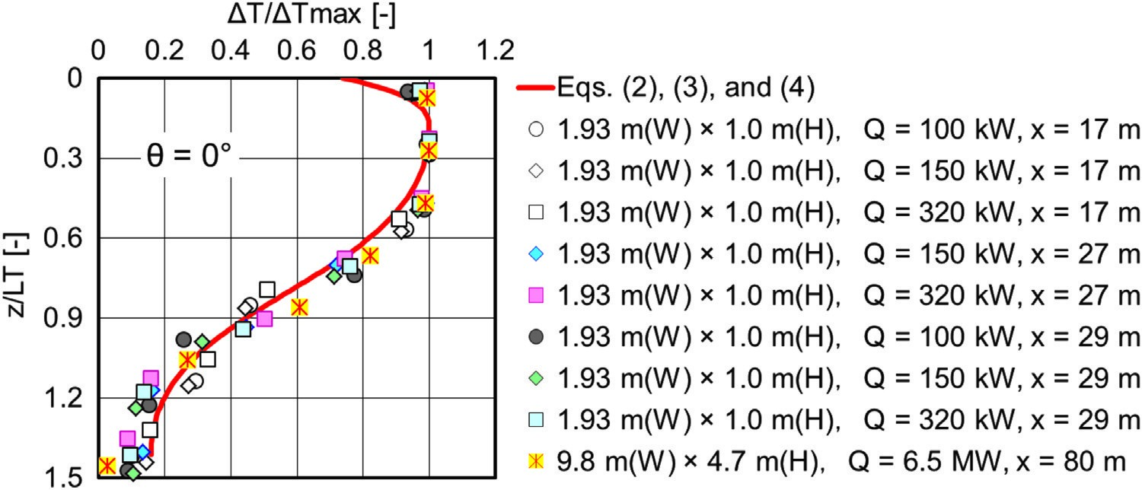

Fig. 14. Application of developed correlation to data obtained in large- and full-scale tunnel.

Fig. 15. Application of correlation represented by Eqs. (3), (4), and (6)–(8), which consider effect of inclination, to data obtained in an inclined small-scale tunnel with LPG fuel.

cross-section with a width:height ratio of about 2:1. Our con- the fire source in the horizontal tunnel. We noted similar changes clusions are as follows: in the temperature distribution in the inclined tunnels.

3) By normalising the temperature rise and the distance from the

1. 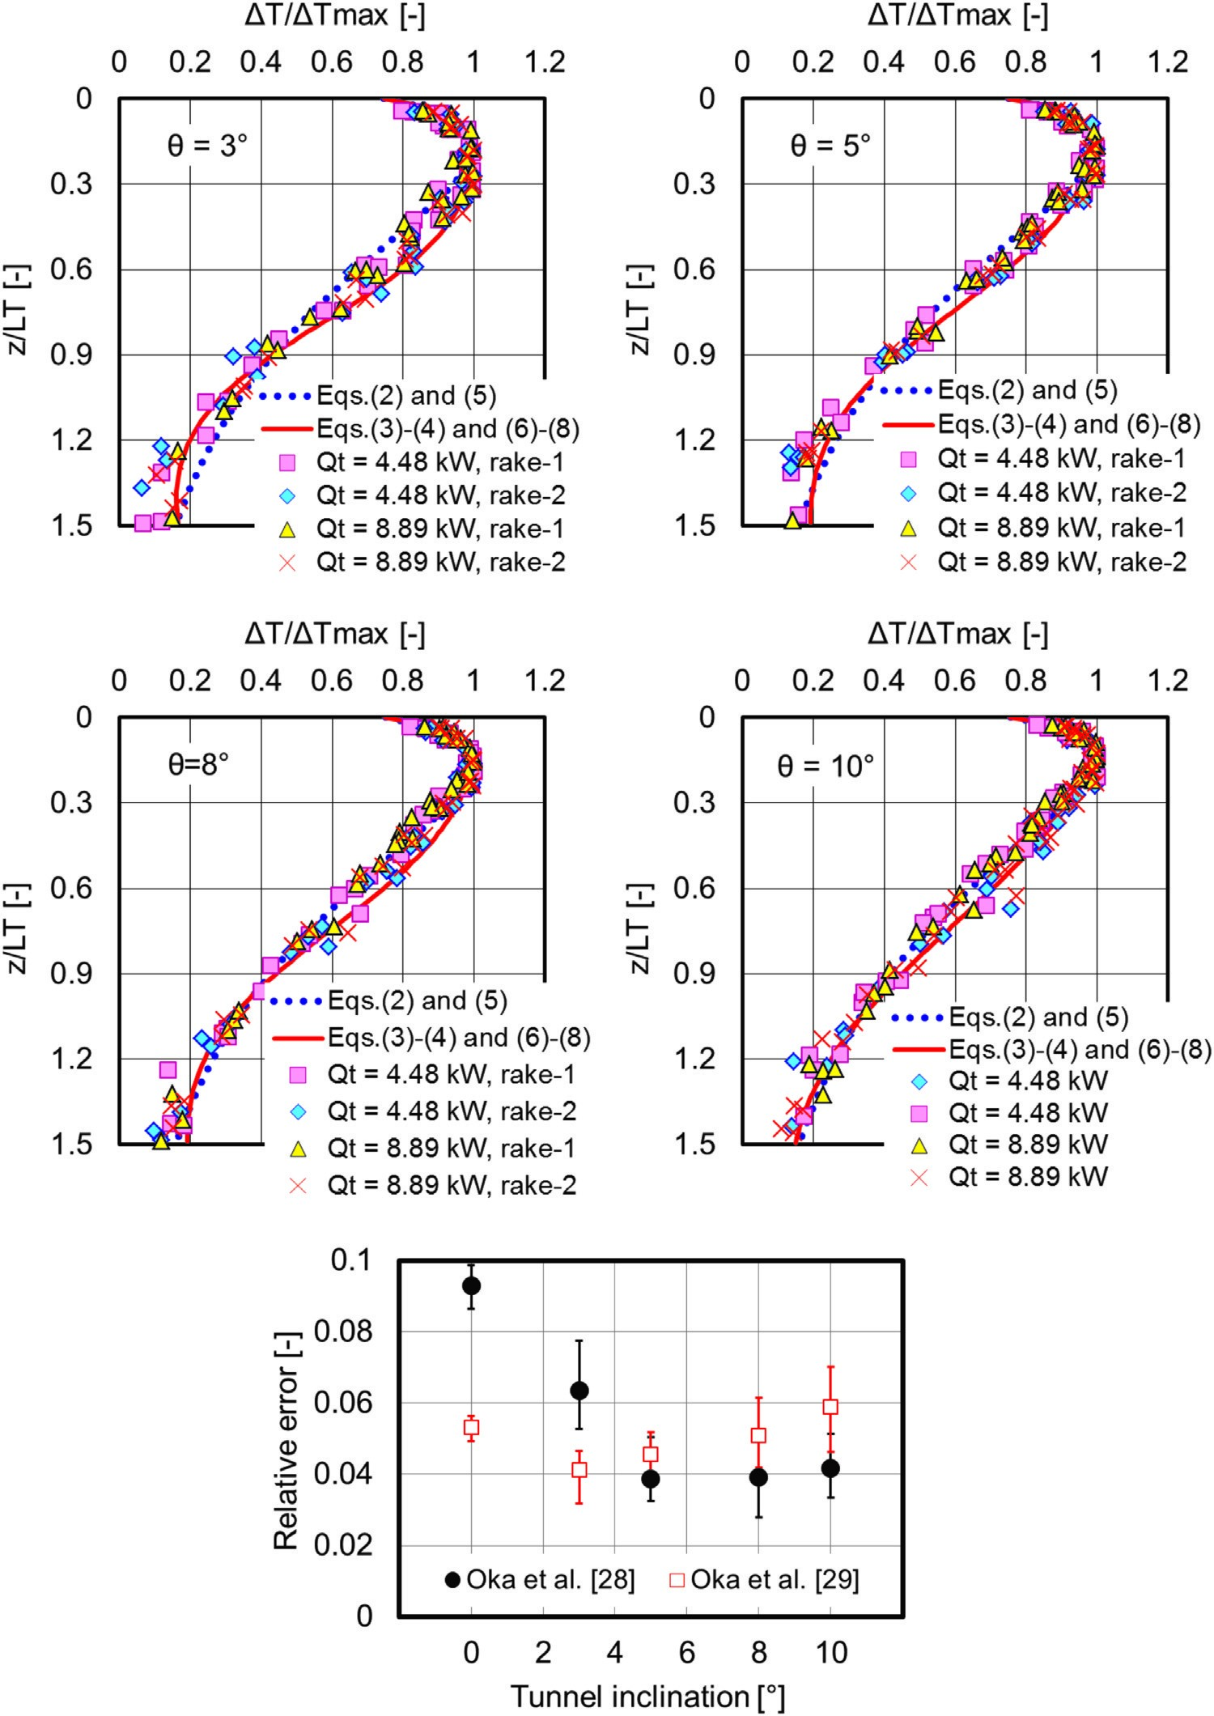The measured temperature distributions in the direction per- tunnel ceiling using the maximum temperature rise, Δ*T*max, and pendicular to the tunnel ceiling were compared with those of the thermal thickness, LT, respectively, at each point at which ceiling jets under an unconfined smooth ceiling. The tem- the temperature distributions were measured, the similarity in perature distribution of a ceiling jet in a horizontal tunnel ex- the temperature distribution was maintained regardless of the hibits a more bulging shape than that under an unconfined distance from the fire source or the heat release rate for each ceiling, but this bulging gradually decreases as the tunnel in- tunnel inclination.

clination increases. 4) The temperature distribution within the ceiling jet changes

1. The convex temperature distribution changes from a pointed shape from a bulging shape to an exponential shape with an increase to a gently decreasing shape with an increase in the distance from in the tunnel inclination.

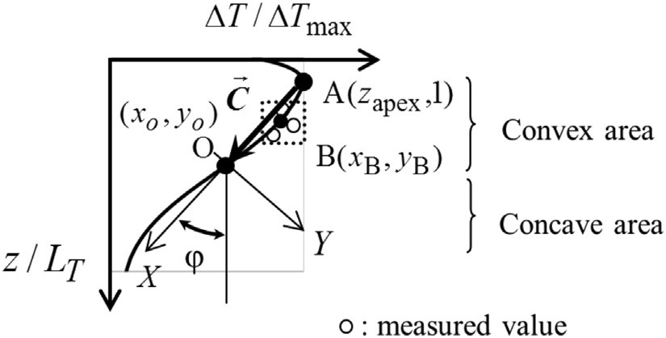

Fig. A-1. Global coordinate system (*z L*/ *T*, Δ Δ*T T*/ max) and local coordinate system (*X Y*, ).

5) We propose a new correlation to represent the temperature distribution that considers the effect of the tunnel inclination, and which is composed of an exponential function and a cubic function with coordinate transformation.

# Acknowledgement

This research was conducted with the support of the Joint Usage/Joint Research Centre of the “Research Center for Fire Safety Sciences”, Center for Fire Science and Technology, Tokyo University of Science. Part of this work was conducted with the support of the Grants-in-Aid for Scientific Research (Basic research B, No. 23310108). The authors would like to thank Mr. Kosuke Inagaki and Ms. Kyoko Kamiya, graduate students of Yokohama National University, for their help in carrying out the experiments.

# Appendix

We inferred the following procedure for using the least-squares method to calculate the values of the parameters in the function.

As shown in Fig A-1, we define the local coordinate system

(*X Y*, ), the global coordinate system (*z L*/ *T*, Δ Δ*T T*/ max), the origin of the local coordinate system, O, and the position where the maximum value appears, A. Here, coordinates in the global coordinate system of O and A are denoted as (*x*0, *y*0) and (*z*apex, 1), respectively. To represent the characteristics of the attenuation range (*x* ≥ *z*apex), which corresponds to a region of concavity and convexity, a cubic function shown in Eq. (A-1) in the coordinate system (*X Y*, ) is defined. This function is converted to the

(*z L*/ *T*, *Δ ΔT*/ *T*max) coordinate system by coordinate transformations of rotation and translation. The values of the coefficient of the cubic function were determined so that the X-intercept of the coordinate system (*X Y*, ) passes through point A.

|  |  |
| --- | --- |
| *Y* = *aX X*( + *b X*)( − *b*), *b* ≥ 0 | (A-1) |
| ⎢  ⎡⎢Δ Δ*T Tz L*// *T*max⎤⎥⎥⎦ =⎡⎣⎢cossin *ϕϕ* −cossin*ϕϕ*⎥⎦⎤⎢⎣⎡*YX*⎤⎥⎦ +⎡⎢⎣*xy*00⎤⎦⎥  ⎣  ⎛ ⎞  Δ*T γ* ⎜ *z* ⎟  (*x* ) exp | (A-2) |

= *α* + *β* ⎝−*η*⎠

Δ*T*max *LT* (A-3)

1. The measured data is enclosed in every small zone, as shown in Fig A-1, to calculate the approximate value of the origin coordinate *O*(*x*0, *y*0). The mean value of the coordinates of this enclosed measurement data, for example, *B x*( *B*, *yB*), is calculated.
2. As *z*apex in *A z*( apex, 1) corresponds to the extremum of the exponential function in Eq. (A-3), we obtain the value of *zapex* by differentiating Eq. (A-3)→ with respect to x, as *zapex* = *γ η*/ − *β*.
3. Denoting vector AO as *C* , the constant *b* in Eq. (A-1) becomes

→ →

*b* = *C* , the absolute value of vector *C* . Taking the components

→

of vector *C*→as [*C Cx*, *y*], the elements of the rotation matrix are→ cos *ϕ* = *C / Cx* and sin *ϕ* = *C / Cy*.

1. The value of (*z L*/ *T*, Δ Δ*T T*/ max) in the global coordinate system corresponding to(*xB*, *yB*) in the local coordinate system is estimated by the transform of Eq. (A-2) and the values of coefficient a and b are determined by substituting these values into Eq. (A-1).
2. Steps (1)–(4) are repeated until the relative error between the values measured and those computed by using Eqs. (A-1) and (A-2) satisfies the condition, as given by Eq. (A-4).

*n*1∑*i* {*yi* − *f x*( *i*)}2 /*y*¯ < *ε* (A-4)

here *xi* = (*z L*/ *T i*) , n is the number of measurement values, f(xi) is the predicted value using Eqs. (A-1) and (A-2) for measured value xi, yi is the measured value (*yi* = Δ Δ( *T T*/ max)*i*), *y¯* is the mean of the measured values, and ε is the convergence test value.

# References

1. A. Beard, R. Carvel, Handbook of Tunnel Fire Safety, Second edition, Part I: Real tunnel fires, ICE publishing, 2011.
2. R.J. Bettis, S.F. Jagger and A.J.R. Macmillan, Interim Validation of Tunnel Fire Consequence Models; Summary of Phase 1 Tests, HSL Report IR/L/FR/94/2, 1994.
3. R.J. Bettis, S.F. Jagger and Y. Wu, Interim Validation of Tunnel Fire Consequence Models: Summary of Phase 2 Tests, HSL Report IR/L/FR/93/11, 1993.
4. X. Guigas, and A. Weatherill, Dynamic fire spreading and water mist tests for the A86 East Tunnel, in: Proceedings of the 5th International Confernce on Tunnel Fires, pp. 261–270, 2004.
5. [H. Ingason, A. Lonnermark, Y.Z. Li, Model of ventilation](http://refhub.elsevier.com/S0379-7112(14)00153-2/sbref2) [flows during large tunnel](http://refhub.elsevier.com/S0379-7112(14)00153-2/sbref2) [fires, Tunnel. Undergr. Space Technol. 30 (2012)](http://refhub.elsevier.com/S0379-7112(14)00153-2/sbref2) [64–73.](http://refhub.elsevier.com/S0379-7112(14)00153-2/sbref2)
6. [A. Lonnermark, H. Ingason, Gas temperatures in heavy goods vehicle](http://refhub.elsevier.com/S0379-7112(14)00153-2/sbref3) [fires in tunnels, Fire Saf. J. 40 (2005) 506–527.](http://refhub.elsevier.com/S0379-7112(14)00153-2/sbref3)
7. [O. Megret, O. Vauquelin, A model to evaluate tunnel](http://refhub.elsevier.com/S0379-7112(14)00153-2/sbref4) [fire characteristics, Fire Saf. J. 34 (2000) 393–401.](http://refhub.elsevier.com/S0379-7112(14)00153-2/sbref4)
8. [T. Kikumoto, N. Kawabata, D. Maruyama, M. Yamada, Model tests on](http://refhub.elsevier.com/S0379-7112(14)00153-2/sbref5) [fire smoke behavior in a small road tunnel for passenger cars, J. Jpn. Soc. Civil Eng. Div. F 63 (3) (2007) 361–373 (in Japanese).](http://refhub.elsevier.com/S0379-7112(14)00153-2/sbref5)
9. Y. Oka, H. Oka, and K. Matsuyama, Temperature properties of ceiling jet in an inclined tunnel, in: Proceedings of 13th International Conference and Exhibition on Fire Science and Engineering (Interflam 2013), pp. 73–83, 2013.
10. [N. Kawabata, Y. Kunikane, N. Yamamoto, K. Takekuni, A. Shimoda, Numerical simulation of smoke descent in a tunnel](http://refhub.elsevier.com/S0379-7112(14)00153-2/sbref6) [fire, Tunnel Manag. Int. 6 (4) (2003) 45–52.](http://refhub.elsevier.com/S0379-7112(14)00153-2/sbref6)
11. [T. Kikumoto, N. Kawabata, D. Maruyama, M. Yamada, Characteristic of plume behavior in a small section road tunnel only for passenger cars](http://refhub.elsevier.com/S0379-7112(14)00153-2/sbref7) [–](http://refhub.elsevier.com/S0379-7112(14)00153-2/sbref7) [a study by numerical simulation, J. Jpn Soc. Civil Eng. Div. F 63 (4) (2007) 448–459 (in Japanese).](http://refhub.elsevier.com/S0379-7112(14)00153-2/sbref7)
12. [H. Kurioka, Y. Oka, H. Satoh, O. Sugawa, Fire properties in near](http://refhub.elsevier.com/S0379-7112(14)00153-2/sbref8) [field of](http://refhub.elsevier.com/S0379-7112(14)00153-2/sbref8) [fire source with longitudinal ventilation in tunnels, Fire Saf. J. 38 (4) (2003) 319–340.](http://refhub.elsevier.com/S0379-7112(14)00153-2/sbref8)
13. [Y. Oka, H. Kurioka, Effect of shape and size of](http://refhub.elsevier.com/S0379-7112(14)00153-2/sbref9) [a](http://refhub.elsevier.com/S0379-7112(14)00153-2/sbref9) [fire source on](http://refhub.elsevier.com/S0379-7112(14)00153-2/sbref9) [fire properties in vicinity of](http://refhub.elsevier.com/S0379-7112(14)00153-2/sbref9) [a](http://refhub.elsevier.com/S0379-7112(14)00153-2/sbref9) [fire source in a tunnel, J. Fire Sci. Technol. 25 (1) (2006)](http://refhub.elsevier.com/S0379-7112(14)00153-2/sbref9) [15–29.](http://refhub.elsevier.com/S0379-7112(14)00153-2/sbref9)
14. [Y.Z. Li, H. Ignason, The maximum ceiling gas temperature in a large tunnel](http://refhub.elsevier.com/S0379-7112(14)00153-2/sbref10) [fire, Fire Saf. J. 48 (2012)](http://refhub.elsevier.com/S0379-7112(14)00153-2/sbref10) [38–48.](http://refhub.elsevier.com/S0379-7112(14)00153-2/sbref10)
15. [Y. Oka, G.T. Atkinson, Control of smoke](http://refhub.elsevier.com/S0379-7112(14)00153-2/sbref11) [flow in tunnel](http://refhub.elsevier.com/S0379-7112(14)00153-2/sbref11) [fires, Fire Saf. J. 25 (4) (1995) 305–322.](http://refhub.elsevier.com/S0379-7112(14)00153-2/sbref11)
16. [G.T. Atkinson, Y. Wu, Smoke control in sloping tunnels, Fire Saf. J. 27 (1996) 335–341.](http://refhub.elsevier.com/S0379-7112(14)00153-2/sbref12)
17. Y. Wu, J.P. Stoddard, O. James, and G.T. Atkinson, Effect of slope on control of smoke flow in tunnel fires, fire safety science, in: Proceedings of the 5th International Symposium, International Association for Fire Safety Science, pp.

1225–1236, 1997.

1. [J.P. Kunsh, Critical velocity and range of](http://refhub.elsevier.com/S0379-7112(14)00153-2/sbref13) [fire-gas plume in a ventilated tunnel, Atmosph. Environ. 33 (1999)](http://refhub.elsevier.com/S0379-7112(14)00153-2/sbref13) [12–24.](http://refhub.elsevier.com/S0379-7112(14)00153-2/sbref13)
2. [J.P. Kunsch, Simple model for control of](http://refhub.elsevier.com/S0379-7112(14)00153-2/sbref14) [fire gases in a ventilated tunnel, Fire Saf. J. 37 (2002)](http://refhub.elsevier.com/S0379-7112(14)00153-2/sbref14) [67–81.](http://refhub.elsevier.com/S0379-7112(14)00153-2/sbref14)
3. [S. Li, R. Zong, W. Zhao, Z. Yan, G. Liao, Theoretical and experimental analysis of ceiling-jet](http://refhub.elsevier.com/S0379-7112(14)00153-2/sbref15) [flow in corridor](http://refhub.elsevier.com/S0379-7112(14)00153-2/sbref15) [fires, Tunnel. Undergr. Space Technol. 26 (2011) 651–658.](http://refhub.elsevier.com/S0379-7112(14)00153-2/sbref15)
4. [Y. He, Smoke temperature and velocity decays along corridors, Fire Saf. J. 33 (1999)](http://refhub.elsevier.com/S0379-7112(14)00153-2/sbref16) [71–74.](http://refhub.elsevier.com/S0379-7112(14)00153-2/sbref16)
5. [L. Li, X. Cheng, C. Wang, H. Zhang, Temperature distribution of](http://refhub.elsevier.com/S0379-7112(14)00153-2/sbref17) [fire-induced flow along tunnels under natural ventilation, J. Fire Sci. 30 (2) (2012) 122–137.](http://refhub.elsevier.com/S0379-7112(14)00153-2/sbref17)
6. [L.H. Hu, R. Huo, H.B. Wang, Y.Z. Li, R.X. Yang, Experimental studies on](http://refhub.elsevier.com/S0379-7112(14)00153-2/sbref18) [fireinduced buoyant smoke temperature distribution along tunnel ceiling, Build.](http://refhub.elsevier.com/S0379-7112(14)00153-2/sbref18)

[Environ. 42 (2007) 3905–3915.](http://refhub.elsevier.com/S0379-7112(14)00153-2/sbref18)

1. J.P. Vantelon, A. Guelzim, D. Quach, D.K. Son, D. Gabay, and D. Dallest, Investigation of fire-induced smoke movement in tunnels and stations: An application to the Paris Metro, Fire Safety Science, in: Proceedings of the 3rd International Symposium on International Association for Fire Safety Science, pp. 907–918, 1991.
2. [T. Minehiro, K. Fujita, N. Kawabata, M. Hasegawa, F. Tanaaka, Backlayering Distance of thermal fume in tunnel](http://refhub.elsevier.com/S0379-7112(14)00153-2/sbref19) [fires, Trans. Jpn. Soc. Mech. Eng. Ser. B 77 (776) (2011) (in Japanese).](http://refhub.elsevier.com/S0379-7112(14)00153-2/sbref19)
3. V. Motevalli and C.H. Marks, Characterizing the unconfined ceiling jet under steady-state conditions: A reassessment, in: Proceedings of the Third International Symposium on Fire Safety Science, pp. 301–312, 1991.
4. L.Y. Cooper, Ceiling Jet-Driven Wall Flows in Compartment Fires, NBSIR 873535, 1987.
5. [Y. Oka, O. Imazeki, temperature and velocity distributions of ceiling jet along an inclined ceiling-Part 1: approximation with exponential function, Fire Saf. J. 65 (2014)](http://refhub.elsevier.com/S0379-7112(14)00153-2/sbref20) [41–52.](http://refhub.elsevier.com/S0379-7112(14)00153-2/sbref20)
6. [Y. Oka, O. Imazeki, Temperature and velocity distributions of ceiling jet along an inclined ceiling-part 2: approximation based on cubic function and coordinate transformation, Fire Saf. J. 65 (2014)](http://refhub.elsevier.com/S0379-7112(14)00153-2/sbref21) [53–61.](http://refhub.elsevier.com/S0379-7112(14)00153-2/sbref21)
7. A. Tewarson, Generation of heat and gaseous, liquid, and solid products in fires, The SFPE Handbook of Fire Protection Engineering, Fourth Edition, Section 3, Chapter 4, p.3–166, 2008.
8. [Y. Oka, N. Kakae, O. Imazeki, K. Inagaki, Temperature property of ceiling jet in an inclined tunnel, Proc. Eng. 62 (2013) 234–241.](http://refhub.elsevier.com/S0379-7112(14)00153-2/sbref22)
9. [J.G. Erikson, R.I. Karlsson, J. Person, An experimental study of a two-dimensional plane turbulent wall jet, Exp. Fluid 25 (1998)](http://refhub.elsevier.com/S0379-7112(14)00153-2/sbref23) [50–60.](http://refhub.elsevier.com/S0379-7112(14)00153-2/sbref23)